Welcome to

**Git-Gut-At-Math**

Table of Contents

Introduction 2

The general view 2

Multiple functions at the same time 3

The function graph zoom 3

Others 3

The Options Panel 4

Derivatives: 4

Integrals: 4

McLaurin Series: 4

Create Function – N-polynomial 5

3D Function view 6

What can you expect (a few examples): 7

Bumps 7

Ripple 7

Parachute 8

Weird Thing 8

Normal Distribution 9

Machine Learning 10

# Introduction

Git-Gud-At-Math is a program that help with solving mathematical problems from Calculus. It can solve derivatives, integrals, McLaurin series, creating n-polynomials, 3D function graphing, normal distribution and a little taste of machine learning.

# The general view

A lot of effort went into a beautiful, user friendly design of the user interface. The project is done with C# and WPF for the UI.

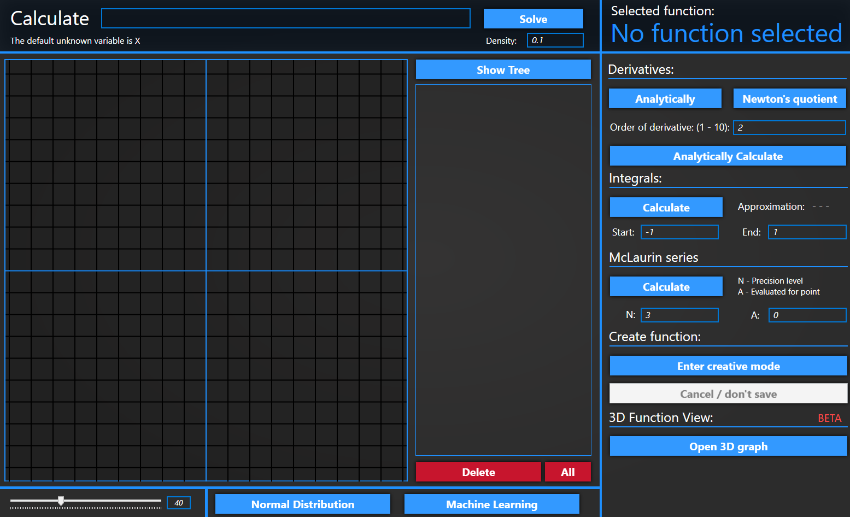

Once you open the program you are greeted by this window where all the main features lie.

The main window is spit in three parts.

1. Header (function input, solve button and the currently selected function)
2. The left part (function graph, function list and all the buttons that help with managing the functions)
3. The options panel – The right part (where all the functions that you can do on one function lie)

## Multiple functions at the same time

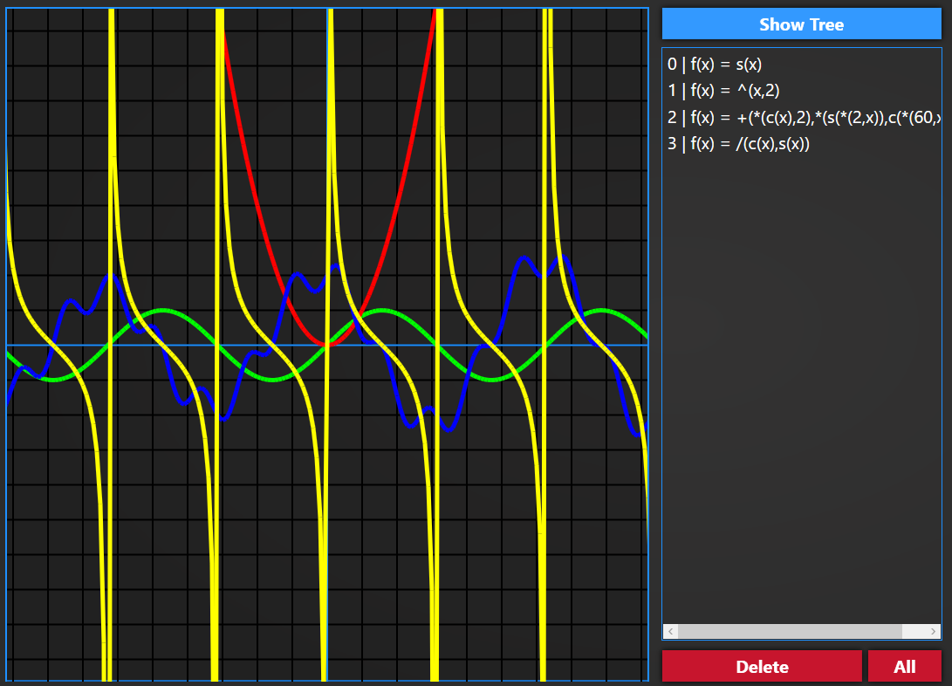You have the ability to work with a lot of functions on the same time. All the currently active functions are listed on the right. You can delete one or all of them at once. On the top right is the “Show Tree” button which will open a new window with the tree representation of the currently selected function.

## The function graph zoom



It is located on the bottom left and the default value is 40. You also have to the ability to zoom on the function graph with the scroll mouse wheel.

## Others



On the bottom middle part are located the two options for normal distribution and machine learning. They will open a new window for each of them.

The other option that opens a new window is the:

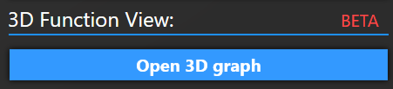  
Even though it is in the options panel it is a separate option which will open a new window with a 3D view for functions. More on this later on.

## The Options Panel

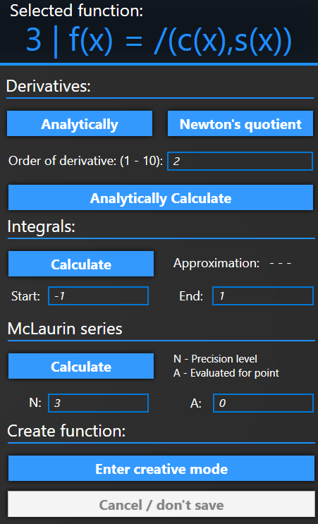

All the options listed here are related to the currently selected function. I think most of them are pretty self-explanatory, but a quick overview wouldn’t hurt.

### Derivatives:

You have three options.

1. Analytically – Solves the derivative of the currently selected function and gives you the new function expressions.
2. Newton’s quotient – Solves the derivative of the currently selected function but gives you a so-called solution function. ONLY the solutions for points NOT the expression.
3. Analytically Calculate – Solves the n-th derivative which is specified in the input box located on top of the button.

### Integrals:

You can specify the start and end for the range it should calculate the integral and the result will appear in the Approximation label

### McLaurin Series:

Two labeled input boxes and calculate button. The new function will be listed and rendered on the graph

## Create Function – N-polynomial

Once you click the “Enter creative mode” button you will enter creative mode :D You can see that when the buttons change states into:

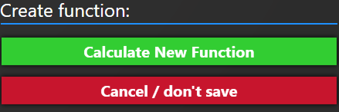

All the function from the graph will disappear but don’t worry they are STILL there but just hidden so you can create your own function.

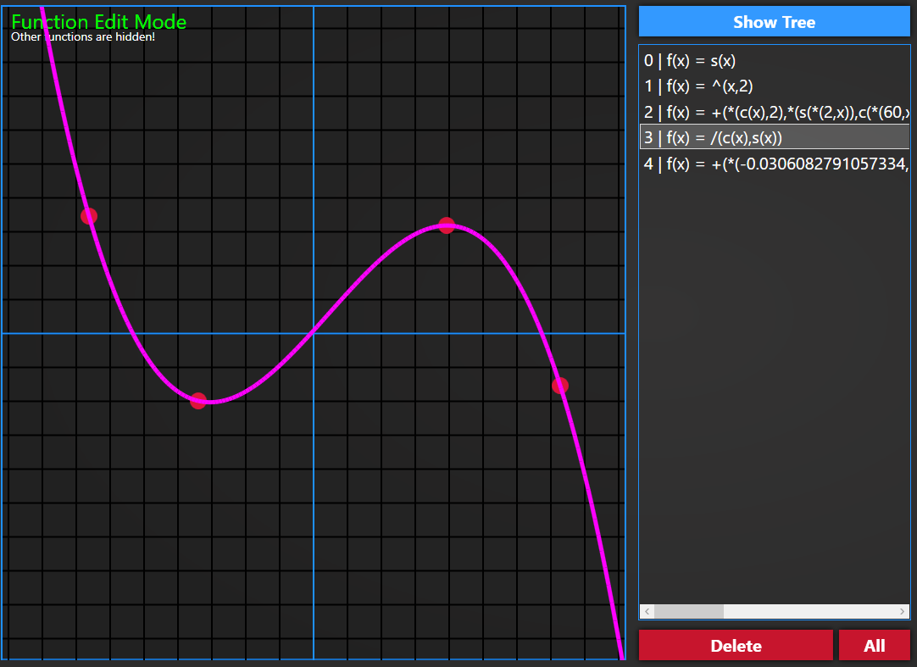

A text on the top left corner of the graph window will appear to let you know that you are in creative mode. Everything here works as expected Once you have clicked where you want the new function to intersect you can click the “Calculate New Function” button which will add a new function to the function list and render it for you. You can also cancel the action by pressing the “Cancel / don’t save” button. After leaving creative mode the function that you have create will still be there.

# 3D Function view

Once you click the “Open 3D graph” button a new window will open:

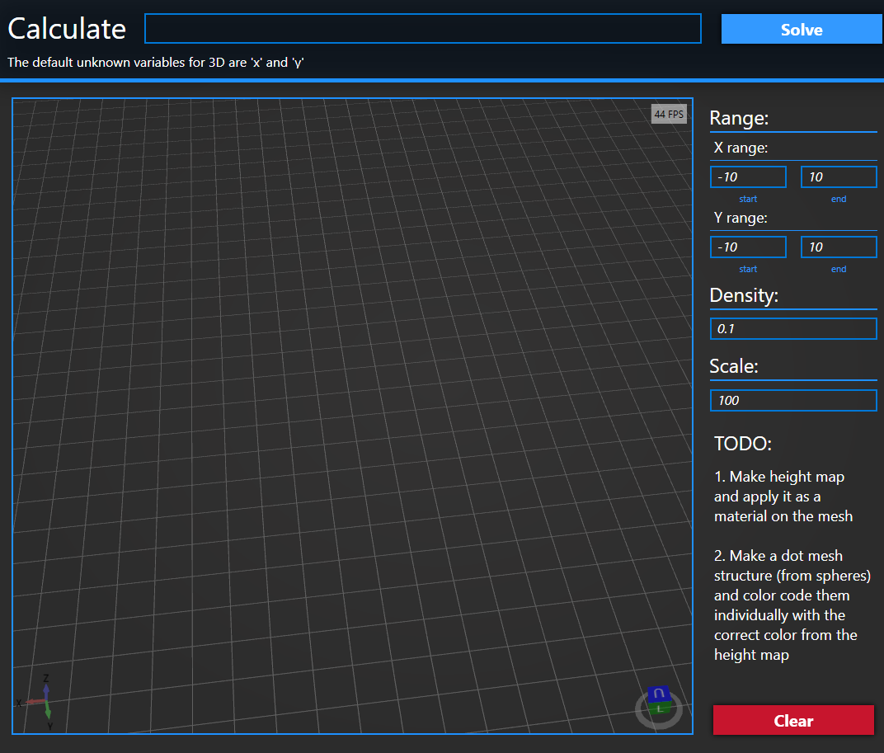

One the top you can type in your function and keep in mind it will be solved according to x,y variables.

You can specify the range to solve for and you can also specify the density lower the value the more detailed is the mesh.

Scale is an option to scale the function because some functions result into big Z values. Scale is implemented so you can counteract that. The bigger the scale the smaller the Z value the smaller the scale the more closely it represents the real function values. If set on 1 it is 1:1 representation.

With the clear button you can clear the currently shown function and calculate for a new one.

## What can you expect (a few examples):

Bumps

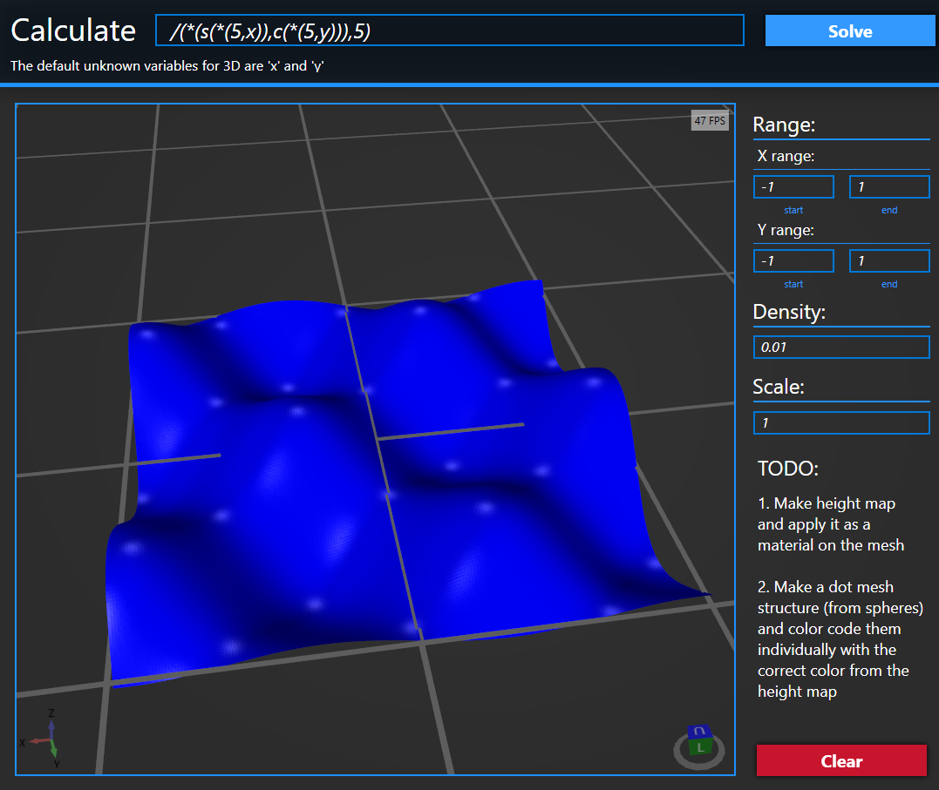

**/(*(s(*(5,x)),c(*(5,y))),5)**

Range X: (-1,1)

Range Y: (-1,1)

Density: 0.01

Scale: 1

### Ripple

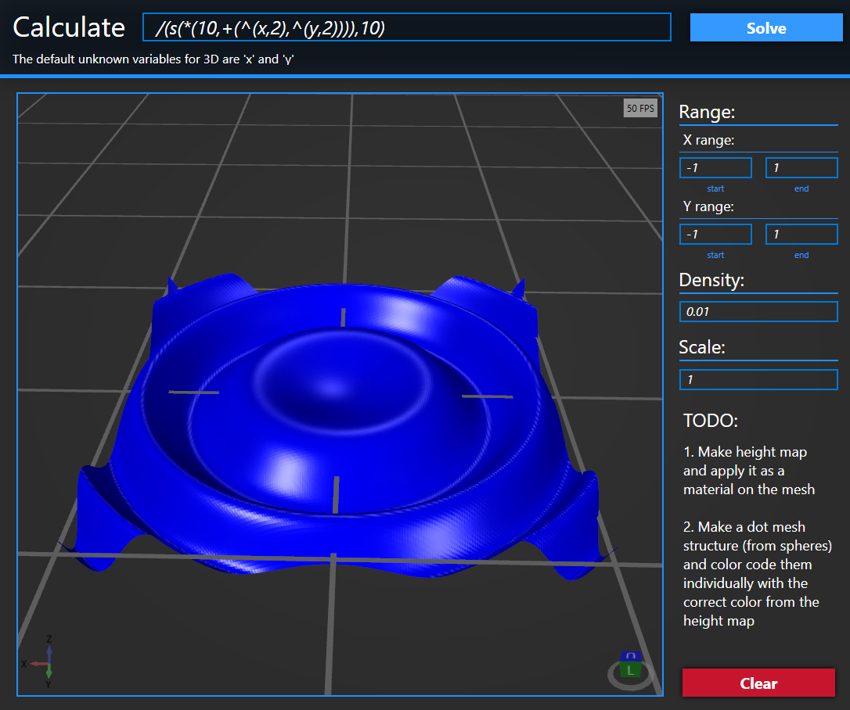**/(s(*(10,+(^(x,2),^(y,2)))),10)**

Range X: (-1,1)

Range Y: (-1,1)

Density: 0.01

Scale: 1

### Parachute

**-(-(0,^(x,2)),^(y,2))** 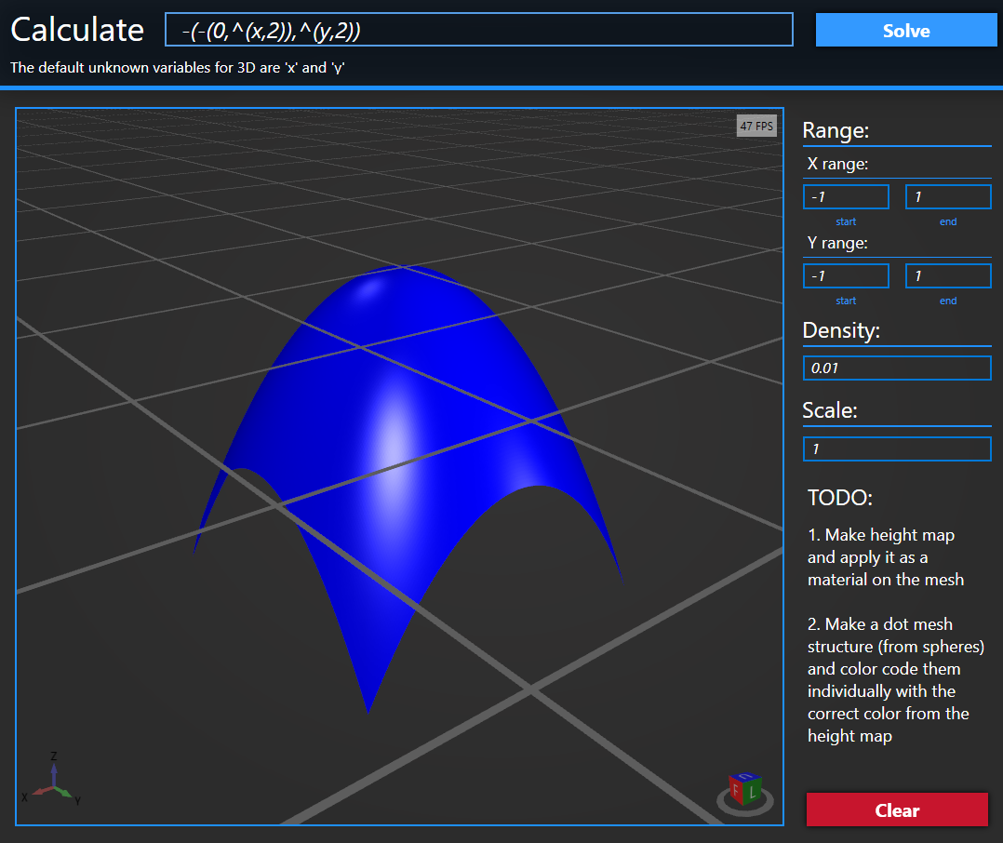

Range X: (-1,1)

Range Y: (-1,1)

Density: 0.01

Scale: 1

### Weird Thing

**-(^(x,2),^(y,2))**  
Range X: (-10,10)  
Range Y: (-10,10)  
Density: 0.1  
Scale: 1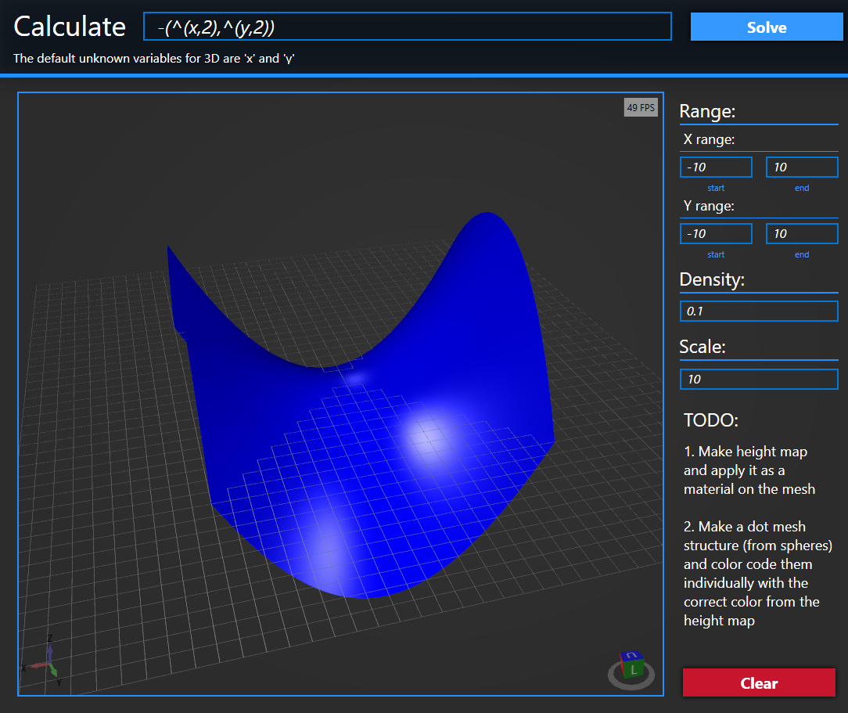0

## Normal Distribution

Once you click the “Normal Distribution” button a new window will open:

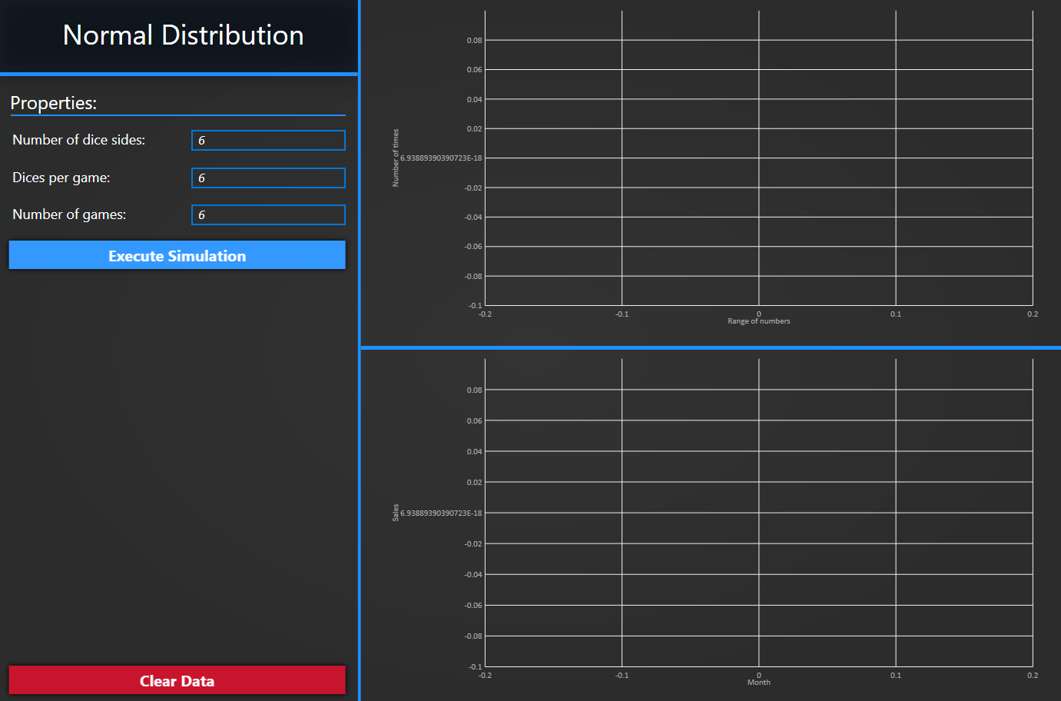

On the left you can specify

1. Number of dice sides
2. Dices per game
3. Number of games

You are able to have multiple calculations at the same time:

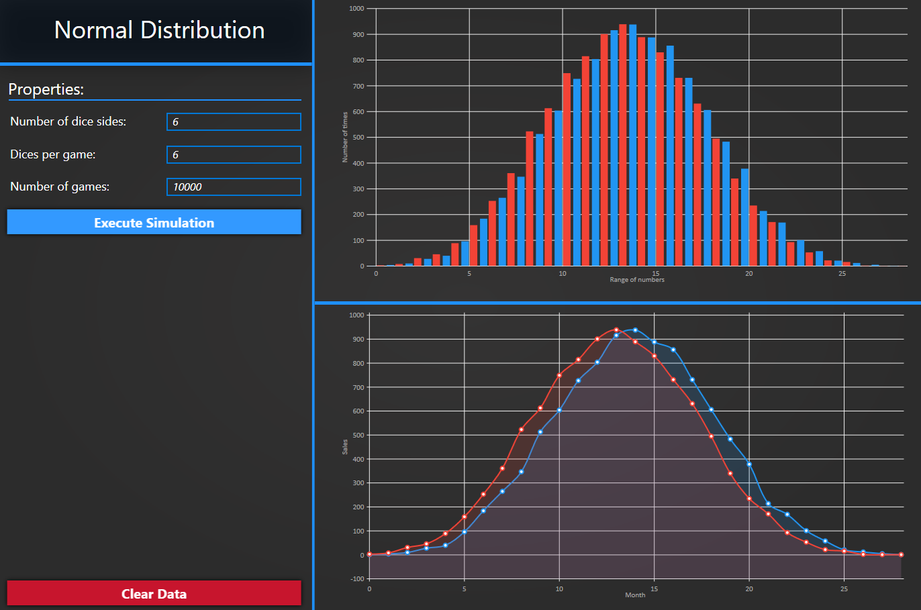

## Machine Learning

Once you click the “Machine Learning” button a new window will open:

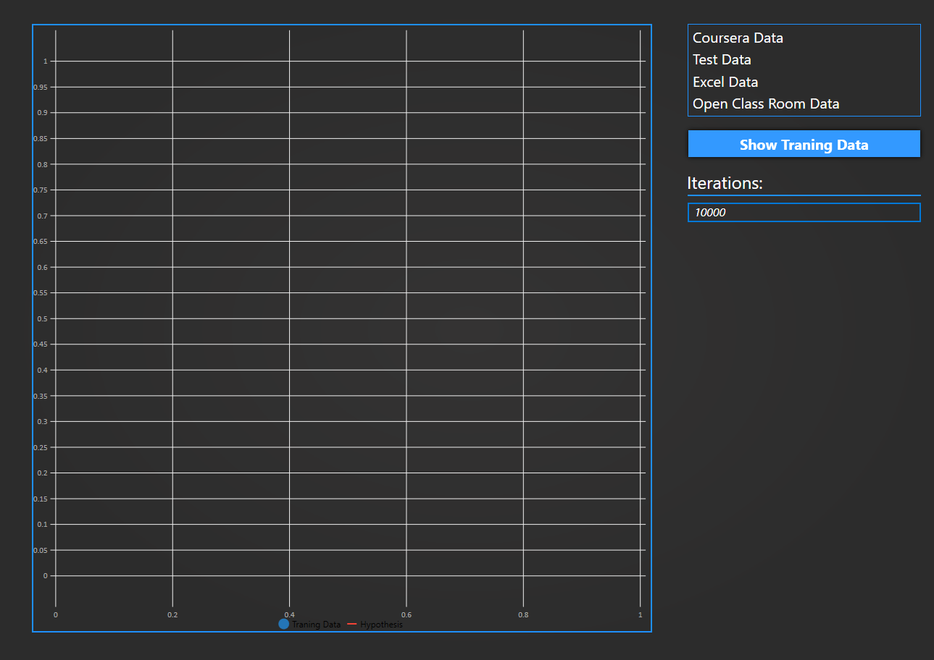

You can choose which data set to use with the list box on the right.

You can also specify how many interventions you would like to have. Recommended is 10 000

